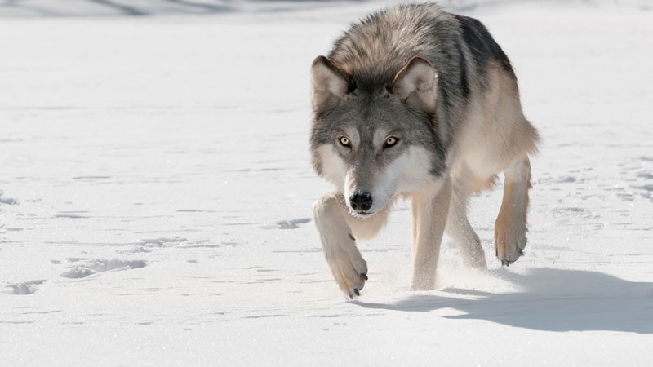Warrenbound: Predator A.I and Movement

This document will explain in great detail how predator A.I should work including how they react to certain situations. This will also explain the predator’s abilities including sight and hearing.

Predator Movement

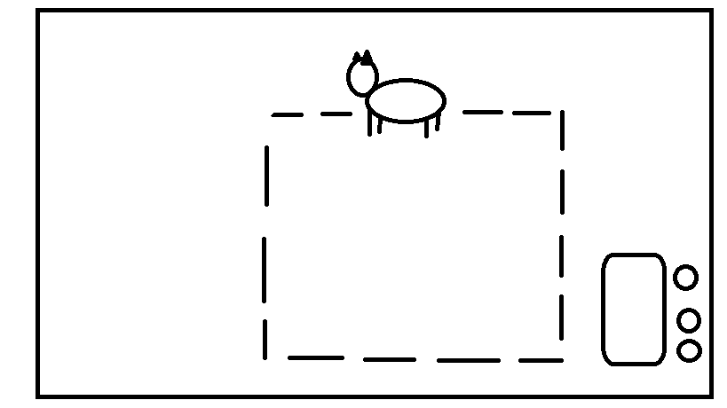Each predator in the game will follow specific movement patterns or routes on the game map. These routes will vary per animal so no predator has to move in a similar route as another. Predators will follow these routes until they are alerted to a rabbit’s presence by either sight or sound. If something catches the attention of a predator’s sight or hearing the predator will stop what it’s doing and go investigate the source. (NOTE: A predator’s reaction will depend on which of its senses was triggered, more detail on this will be given in the sections that talk about sight and hearing.)

This is a simple diagram showcasing what a predator’s movement path may look like

Predator Sight

Sight is shown as a cone that originates from the predator’s head. Players will be able to see the vision cone so that they will know when one of their rabbits is close to being spotted. This cone of sight will be divided into two tiers. The outer most tier is the sighted tier. If a rabbit happens to enter a predators sighted vision the predator will then enter stalk mode. While a predator is in its stalking mode it will move slightly slower than it normally would, but it will now be moving towards the rabbit that caught its attention. If the rabbit moves out of a predator’s sighted tier and avoids being seen any further for an undetermined amount of time, then the predator will move back to its normal route having lost sight of its prey. If a sighted rabbit goes into a hiding place while still in a predator’s sight the rabbit will not be hidden and will be in danger of the approaching predator.

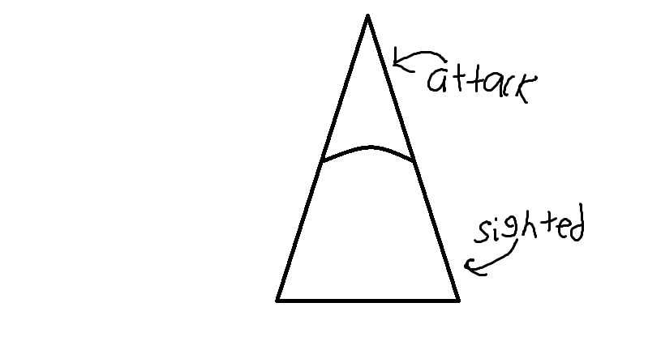The inner most tier is the attack tier. If a rabbit enters the predators attack tier, the predator will then exit its stalk mode and begin its attack. If it’s a wolf it will begin sprinting towards the rabbit and attack once it gets close enough. If it’s the fox it will pounce from its current spot towards the rabbit. (NOTE: The size and range of a wolf’s sight and a fox’s sight will be different from each other and will be determined at a later date. Also an indicator may be added to the U.I screen that will show when predator is stalking or attacking.)

An example of how the vision cone might look in game

Predator Hearing

The second method that predators will be using to detect rabbits will be their hearing. Every action that the rabbits do will make noise. If the generated noise comes into contact with a predator it will stop what it’s doing and begin stalking towards the origin of the noise. If the predator is not able to find anything within an undetermined amount of time after hearing something, then it will return to its regular patrol route. If the predator does find a rabbit, then it will follow its sight behavior. The noise generated from rabbits will be determined by the size of the group. One rabbit moving on its own won’t make much noise compared to a group of six moving at the same time. Add to this if the rabbits are sneaking or sprinting will lower or increase the amount of noise they make. Also if a hiding spot is overcrowded with rabbits then it will make noise alerting predators within hearing range.

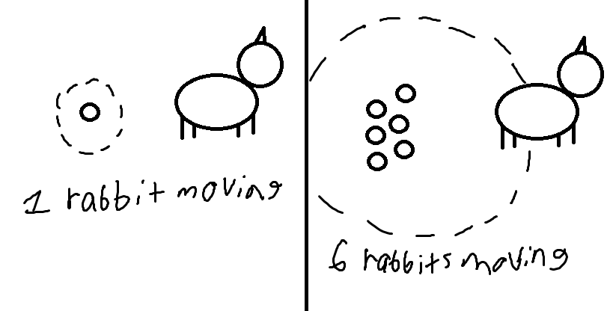

A visual example showing two different cases of rabbits moving behind an enemy. On the left a single rabbit is sneaking and makes it past the predator unnoticed. On the right a group of six rabbits moves together trying to sneak past an enemy. However, in this case much more noise is generated and it alerts the predator. (NOTE: There is no set variable yet that determines the amount of noise made in various situations. This is something that will have to be figured out at a later date through playtesting to properly balance the mechanic.)